1. Introduction
   1. *Purpose and Scope of Project*

The purpose of this e-Commerce website is to provide ease and home spun to people. Homemade accessories (baked items) are very demanding items these days, because of hygiene.

In recent times, e-commerce websites have grown into the trendiest and bountiful form of online trade. It is more frequently known as online retailing and involves a lot customers and stockholders. It provides a comfort platform to purchase goods and services online. This project is basically designed to make the one’s life easy. This software will be used by the educational institutes and inhabitants/plebeians.

This project has a lot of benefits and covers a huge market value. This project is beneficial because of these features:

* It is low in cost.
* It eliminates the travel time of customer.
* It provides abundant information regarding a product.
* It makes easier discrete purchase.

It also makes customers happy by allowing them to sell their undesired products in a reasonable price.

* 1. *Product Overview*

E-Life means Ease for Life. Home is places where you can get anything you want to. But when you are far away from your home in hostel, you have to go to the Market every time you need even just a single item. The goal of E-Life is to provide the shipping facilities to the students at their doorstep.

The user interface of E-Life will contain 8 Sections named as Project Accessories, Computer Peripherals, E-Life Grocery Store, E-Life Book Store, E-Life Stationary Store, Women's Fashion, Men's Fashion and E-Life Special. So, this would be our whole task to do. We will cover each aspect of it in detail.

1. Project Management Plan
   1. *SDLC Used*

In this system extreme programming methodology is chosen which is between one of the four variants of agile methodologies. This methodology provides the best software engineering development practice. It has different values which include communication, simplicity, feedback, courage and respect. The overall product quality is enhanced in this methodology because of the team work. In this methodology the needs of the customer are taken into account by the developing team.

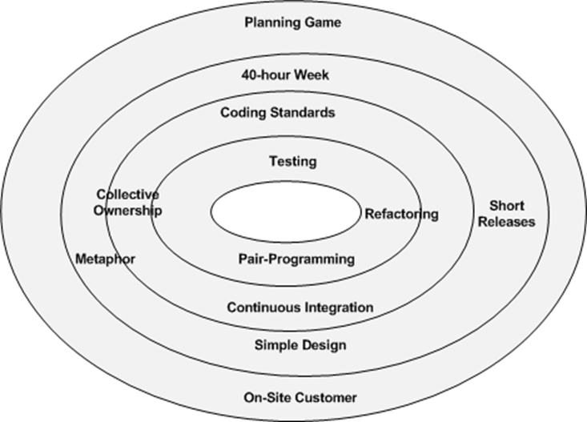

* 1. *Commitment to SDLC*

To the best of our abilities, we followed the rules and regulations of the chosen methodology but somewhere, due to the lack of time, we couldn’t abide by the rules and guidelines provided in the Agile Method.

* 1. *Project Plan*

The proposed work plan of our project was as follows:

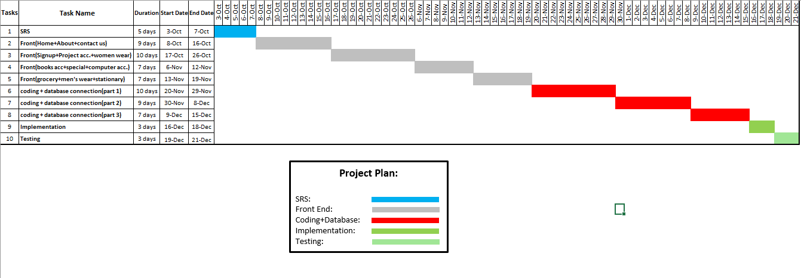

* 1. *Deviation from Project Plan*

The actual work plan of our system is:

*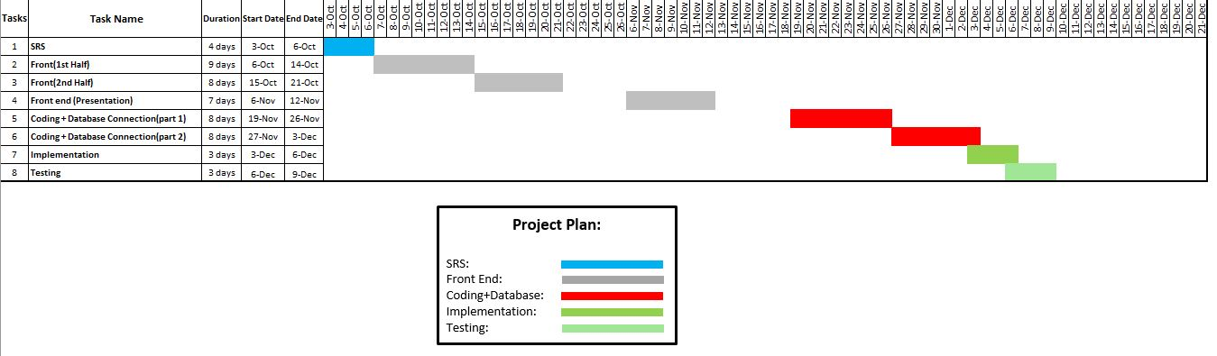*

*Project Contribution*

*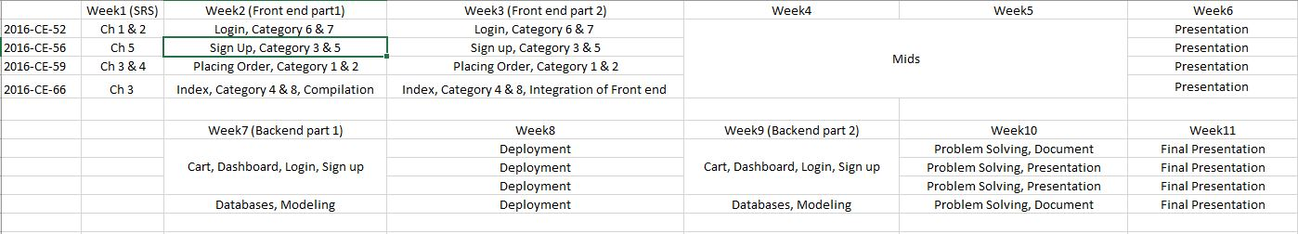*

* 1. *Hardware and Software Resource Requirement*
     1. *Hardware Resource Requirement*
* Operating system: windows
* Hard disk: 1TB
* RAM: 6 GB
* Processor: Intel Inside CORE i5
  + 1. *Software Resource Requirement*
  + PHP
  + Xampp
  + MySQL server
  + Pencil Tool
  + JavaScript
  + jQuery
    1. *Learning Process*

Working as a team, each individual put 100% effort in her domain to complete the project successfully. During the whole time period, each member learn the basics of Sublime, XAMPP and Database.

* 1. *Impact of the Project*

As the name suggests, the project will provide ease to the university individuals. The aim behind this project is to provide comfort to those who travel from far off places just for the sake of knowledge. As best people are those who help others. The project is not meant to provide any harm to a person or organization.

* 1. *Team Coordination*

*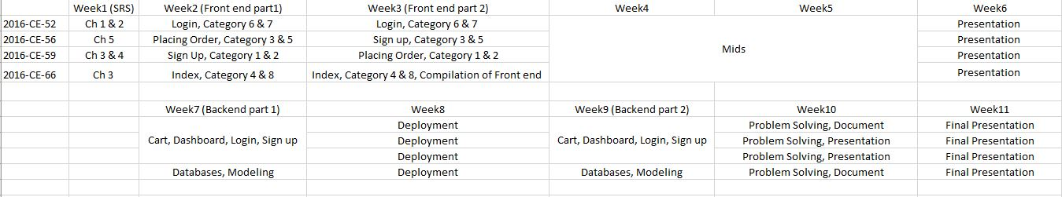*

1. Requirement Specifications
   1. *Stakeholders for the System*

* Marketing Managers
* Web Master
* Content Managers
* Finance Managers
* IT Security Managers
* Consultants
* Social Media holders
* Retail Suppliers
* Transport Suppliers
* Data Warehouse Managers
* Sales Managers
* Project Managers
* Customer Care Managers
* Cloud Operations Handlers
  1. *Actors for the System*
* Admin
* Customers (end users)
  1. *Use Case Model*

Admin

View Orders

View Products

Update Product

Delete Product

Add Product

Add product to Cart

Sign Up/Login

Client

Place Order

View Catalogue

* 1. *Textual Description of each Use Case*
     1. *Admin Login*

Admin would have an account to access and manage the system. He enters the username and password to log in to system. He can add new products to the respective catalogue.

* + 1. *Add a Product*

Admin logged in to the system and can add new products in the database with respect to the catalogue. He can also add specifications of the product, stock and their cost.

* + 1. *Remove a Product*

Admin logged in to the system and can delete existing products in the database with respect to the catalogue.

* + 1. *Update a Product*

Admin logged in to the system and can update existing products in the database with respect to the catalogue. He can also update specifications of the product, stock and their cost.

* + 1. *Search a Product*

Admin logged in to the system and access the specific information about the existing products and can also view the details of the delivered products via query.

* + 1. *User Sign Up*

User would have a sign up window. He will sign up using Name, Email and Phone Number. User must enter valid Name, Email, and phone number.

* + 1. *User Access to the Catalogue*

User must sign up in order to view the catalogue. Once he has created his account by signing up, he can view the catalogue.

* + 1. *Selecting the Product*

User can select the required product by clicking the product to view all details of the product.

* + 1. *Placing the Order*

User will enter the product specifications including name and quantity. Website will also ask the user for the delivery destination.

* + 1. *Tracking Order*

The record of the ordered item will be stored in the database. This can only be viewed by the authorized person.

* + 1. *On time Delivery*

The order will be delivered on time with the shipping charges of RS.100/-

* 1. *Non-Functional Requirements*
     1. *Error Handling*

System will handle the error exceptions.

* + 1. *Performance*
* The system shall accommodate large number of products without any fault.
* Response time will be shorter.
  + 1. *Safety*

System shall not cause any harm to the users. And it will be safe for everyone.

* + 1. *Security*

System will use secured database.

* + 1. *Reliability*

The system will deliver the products on time.

* + 1. *Usability*

The website will be user friendly responsive and efficient.

1. Design
   1. *Graphical User Interface (GUI)*



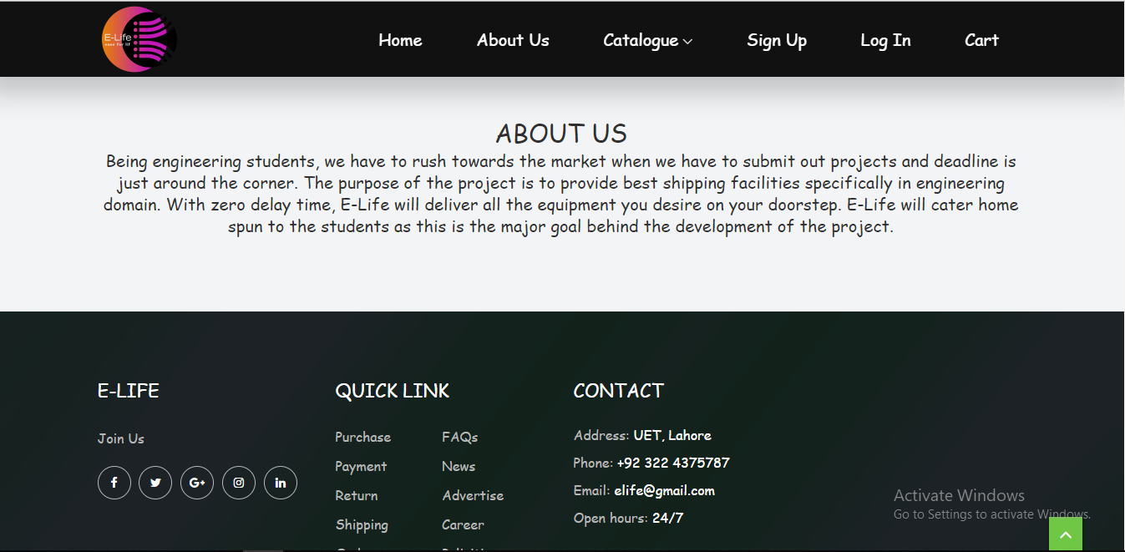

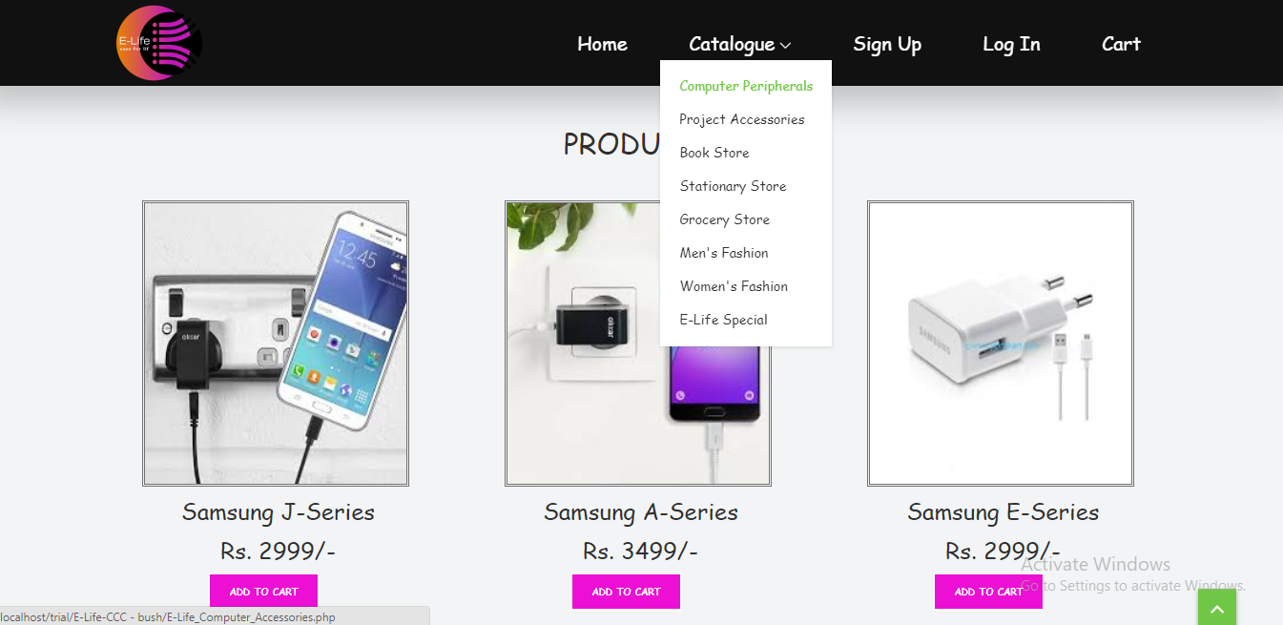

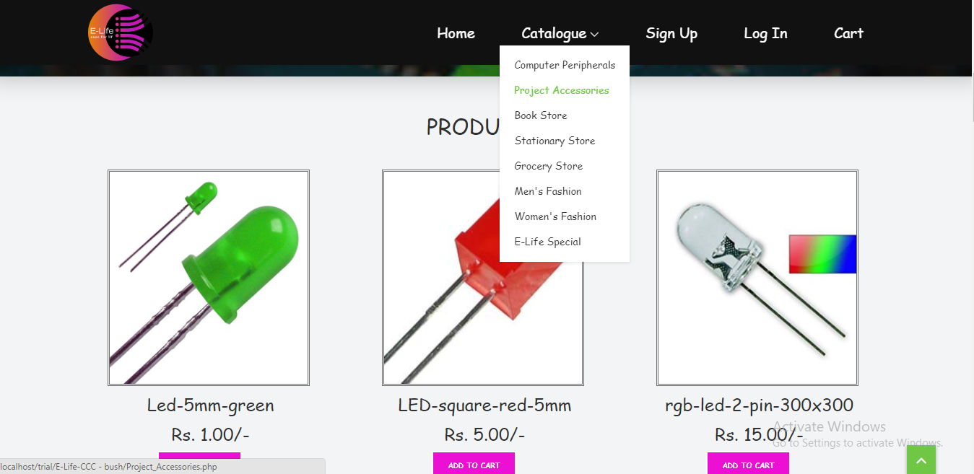

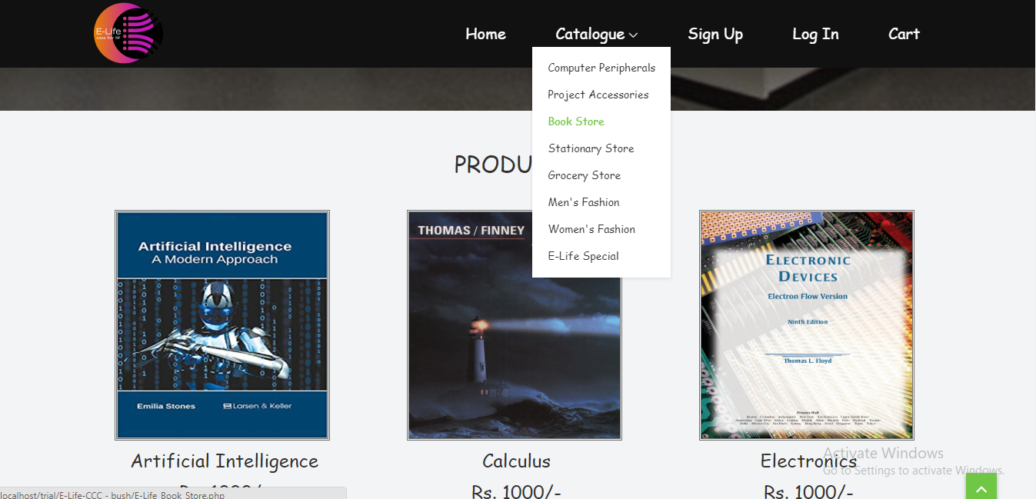

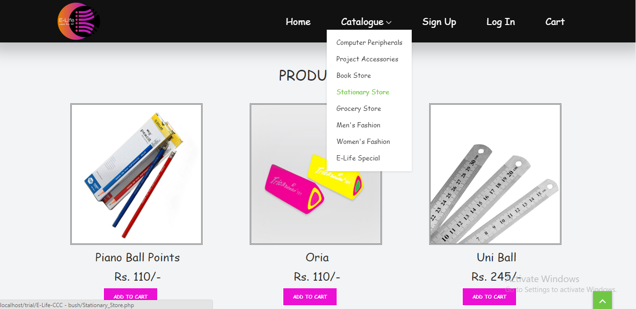

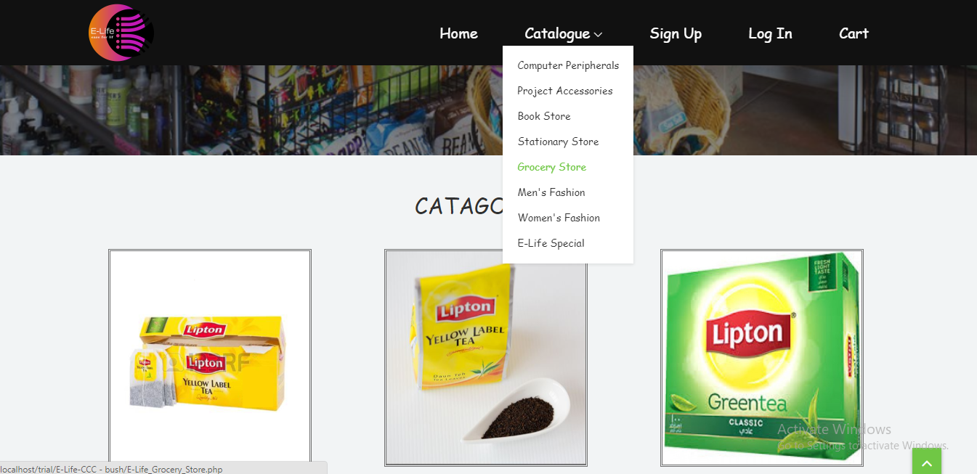

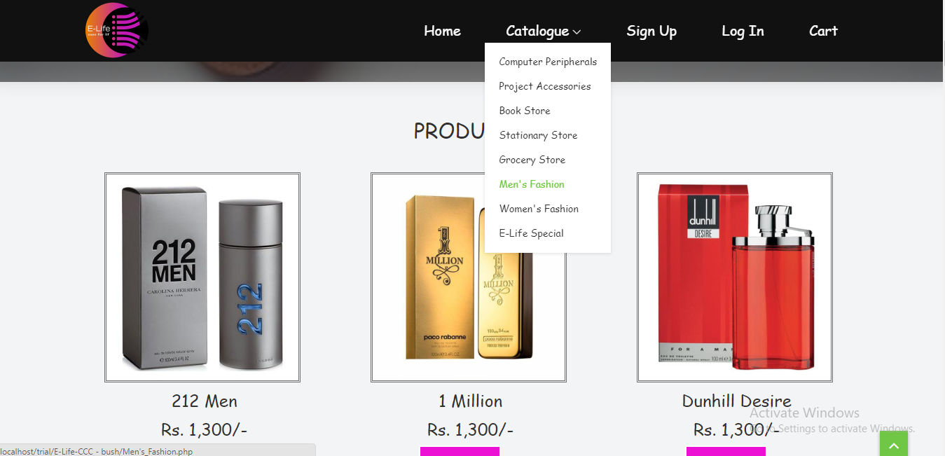

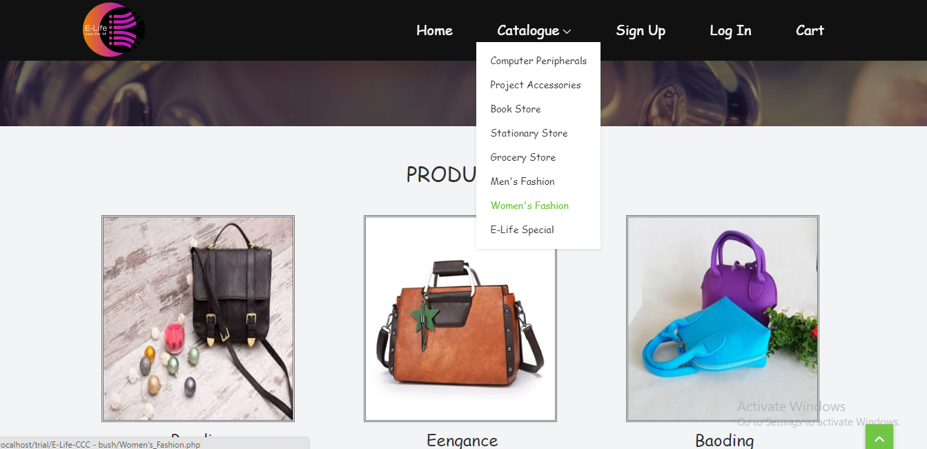

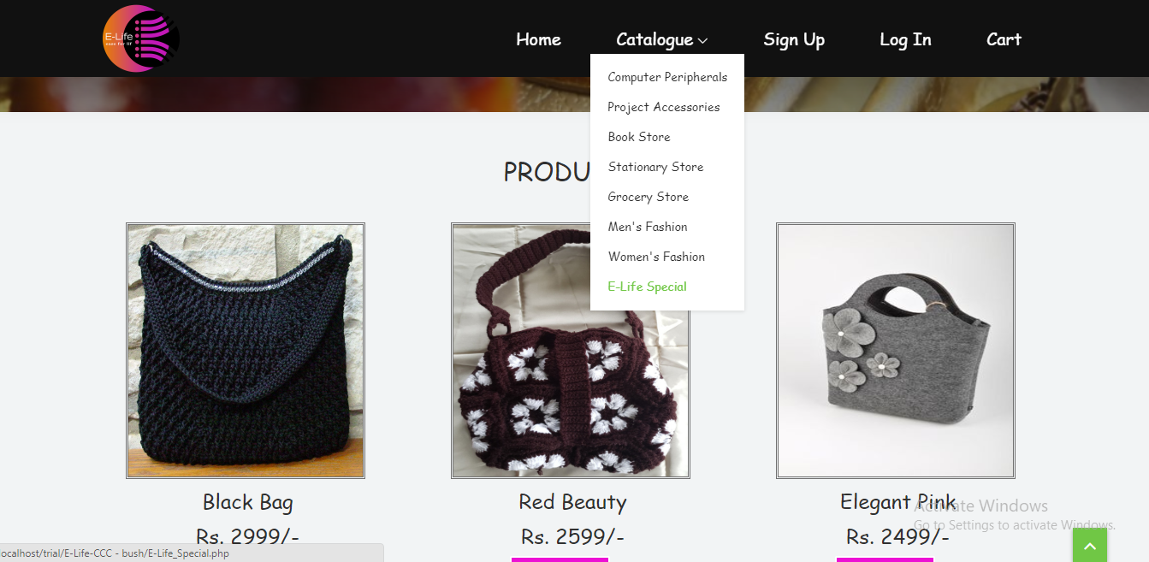

* 1. *Deviation from Proposed GUI*

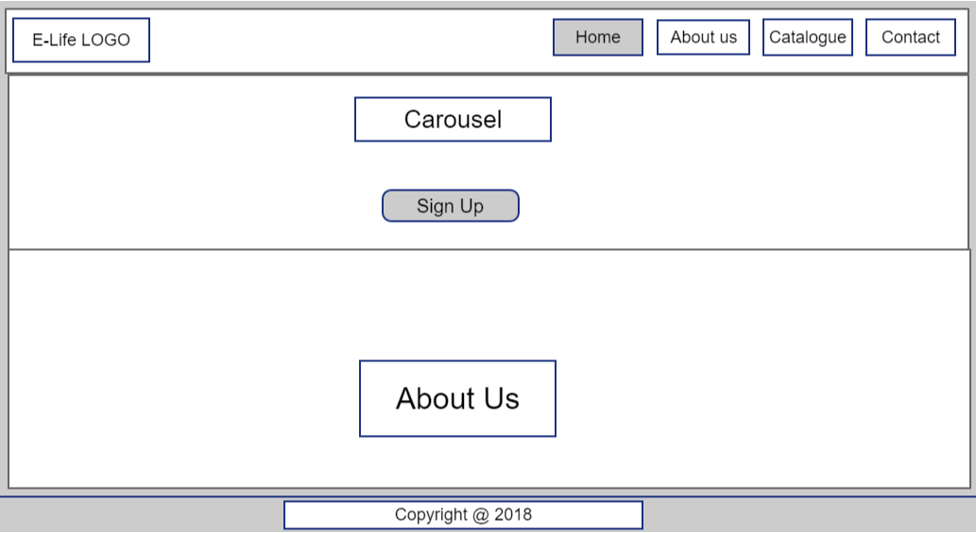

The above figure is the one that we proposed in our system requirements specification document. In that figure, we have mentioned ‘Contact’ in the navigation bar. But we have diverted a little bit and we have put a few new options like ‘Sign Up’, ‘Login’ and ‘Cart’. Actually it is the requirement of our project that we have to mention them in the navigation bar.

* 1. *Class Diagrams*

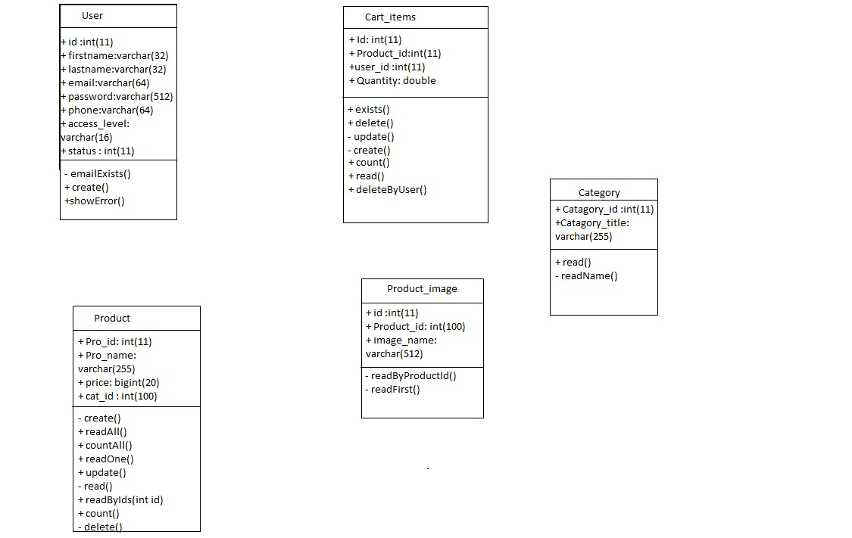

* 1. *Database Diagrams*

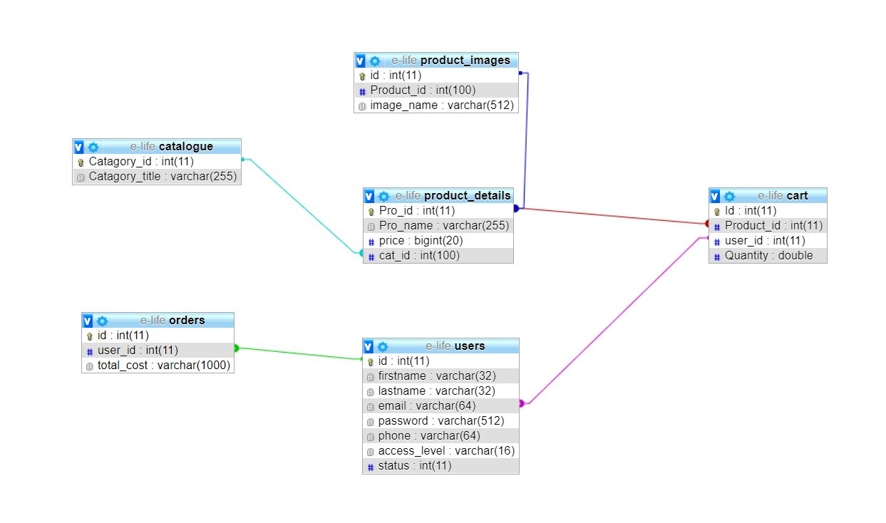

1. Test Plan of the Project

* Log in or sign in to our website.
* Check the home page (main page). It is basically a gate to visit our website.
* Without login, you can visit our website but when it comes to the shopping then you have to sign in or login.
* Test that all the pages are linked with each other.
* Then visit any of the pages that we offered on the home page.
* While log in, there is a check that if admin has logged in then it will access directly to the dashboard.
* But if user (customer) has logged in then the one will get access to the home page.
* After that, one will select any product and added it to cart.
* The selected item will be shown in the cart items of that user.
* On the cart items page, the user will have right to remove product from the cart.
* On the cart items page, the user will also have right to checkout.
* Once the user pressed the checkout button, one’s cart data will have been shifted to cart database.
* After that the user order has been placed out.

Bugs are traced during the testing. We tried our level best to ensure that the project will work in a perfect manner. To read those errors and apply a removal formula on those bugs would be the solution.

1. Deployment
   1. *Git Repository*

<https://github.com/ElifeProject>

* 1. *Deployment Plan*

We have deployed our project on computers/laptops of group mates successfully. First we have found the IP address. Then by using IP address, we have accessed all the files of the project. In this way we deployed our website.

While our database deployment is quiet tricky. What we have done is open the Xampp control panel. From there we have put changes in the Apache-httds-config and set the ‘require all granted’. Then restart the Xampp server. After that we write the IP address of that computer of which we want to access database and open it. In this way, we deployed our database successfully.

* Syntax: IP address/phpmyadmin (for the deployment of database)
* Syntax: IPaddress/trial/E-Life-CCC/index.php